Game Developer Intern Exam

Game Design Document

# Table of Contents

**Table of Contents** **2**

**Summary** **3**

**Gameplay** **4**

**Levels** **5**

**Art** **6**

**UI, Systems & Options** **7**

**Development Plan** **9**

# Summary

No name was given to the application but it serves as a clone to the popular hole.io game that captivated people from around the globe.

# Gameplay

## Core Loop

You devour enemies in order to increase your size while avoiding those who are larger than you.

## Mechanics

You will be given sixty seconds to eat the obstacles littered around the environment to increase your score.

The more you eat the more you grow larger until the time countdowns to zero.

## Enemies

**Speed:** it will sprint in a random direction.



**Stoic:** Serves as a static entity that does not move after being instantiated.

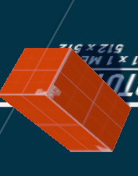

**Big Circle:** Is a big circle that cannot be eaten until a certain level has been reached.

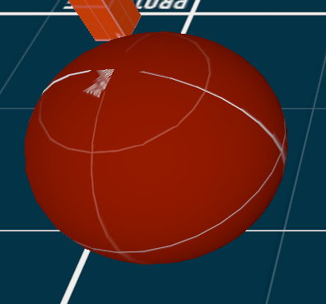

# Levels

## Level Progression

The player gains a level every time you reach the target score.

## Environments

The environment will be viewed directly from above to give the player a better perspective on where to maneuver its movement. The environment will also be rendered in a minimap on the right side of the UI in order for the player to have a clear view of the environment.

# Art

## Summary

Simple geometry was used to convey the style of the game.

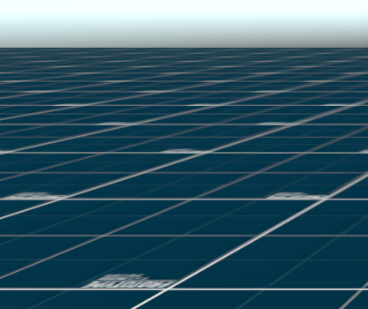

The ground material used was a free asset pack on the unity asset store.

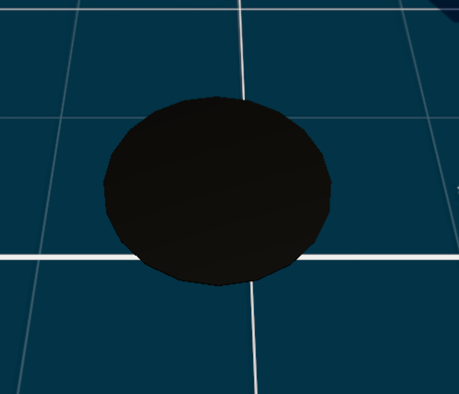

The player character has a basic material shader that is dark colored.

# UI, Systems & Options

## UI

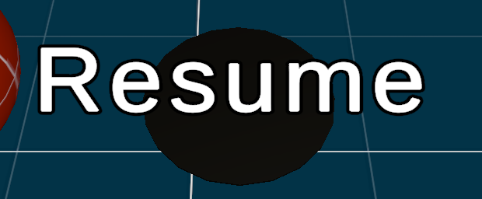

Resume Button:



Pause Button:

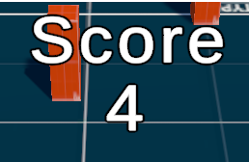

The score text that keeps track of the score

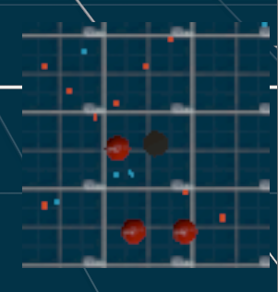

The minimap that gives you a brief overview of where the enemies you want to eat are.

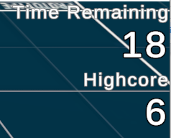

This keeps track of your remaining time and highscore that gets saved after you pass your initial score.

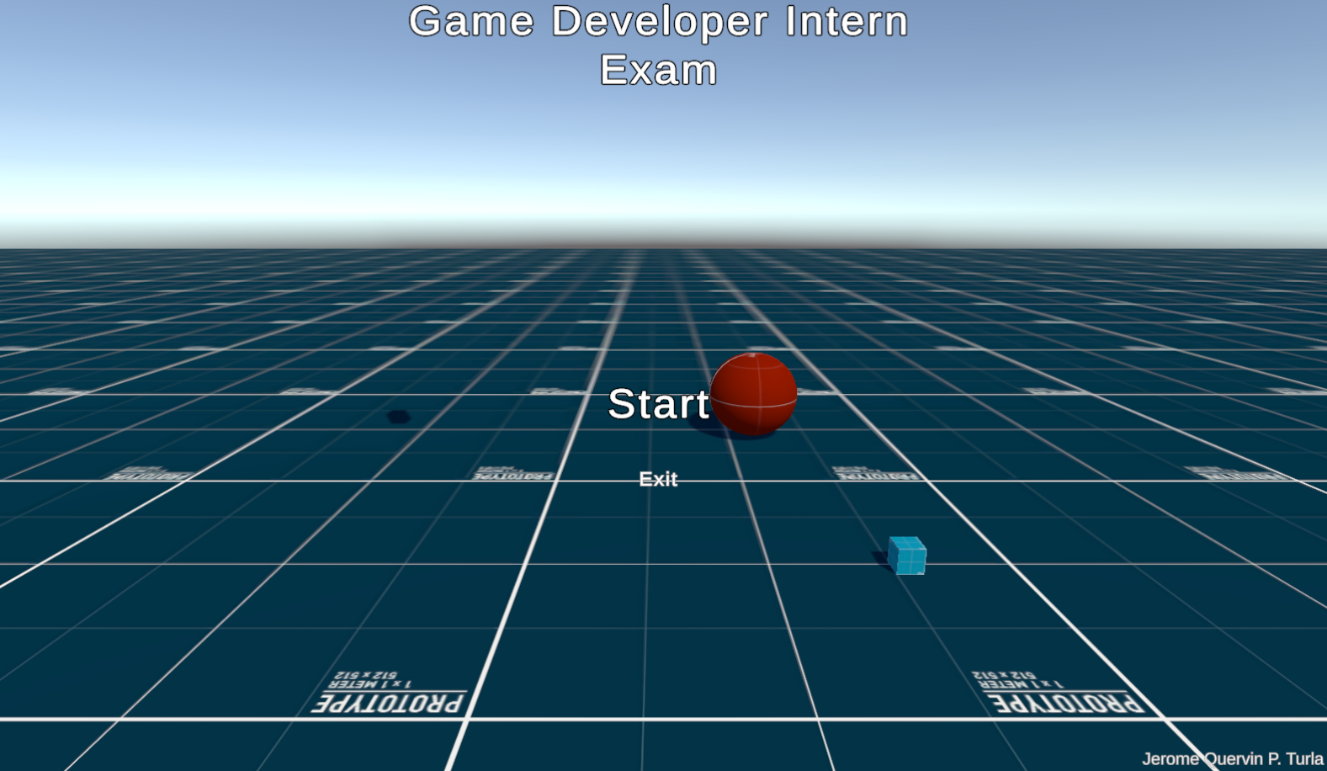

The main menu of the application.

# Development Plan

## Vertical Slice

